___________________________________________________________________________________

Policy on Sports Induced Concussions

Title: | Sports Induced Concussions
Policy number: | POL 043
Approval(s) required | Academic Senate Board of Trustees Both
Date of Senate approval if required | N/A
Date of Board approval if required | 13/12/2023
Effective date of implementation | 08/01/2024
Frequency of review required | 3 years
Replacing or superseding information
Revision number | New
Responsible Office | Department of Athletics
Accountable Officer | Director, Athletics
Related legislation, regulation, policy, or policies | List of relevant legislation, regulation and policies that are referenced by or impacted by this policy.
Link(s) to the Strategic Plan | Yes No
If Yes, identify which goal(s)
Appendix/Appendices | A. Sport Concussion Assessment Tool 5 (SCAT5)  B. NCAA’s Concussion Fact Sheet for Student-Athletes  C. Student-Athlete Concussion Statement  D. NCAA’s Concussion Fact Sheet for Coaches  E. Coaches Concussion Statement  F. References

- Authority
Board of Trustees
- Purpose
To enable The University of The Bahamas Athletics Department to assess and identify those student athletes who have suffered a sports induced concussion.
- Scope
This policy applies to all student athletes of University of The Bahamas.
- Definitions
Sports Related Concussion (SRC): the 5th International Conference on Concussion in Sport defines a Sports Related Concussion as a traumatic brain injury induced by biomechanical force.
- Policy Statement
  - Baseline Testing
    - All incoming freshman or those first time entering UB student athletes who are participating in those sports which have been identified as a contact or collision sport and/or who have had a previous history of concussions as identified by their health history will have a baseline neurocognitive test and balance test performed as part of their athletic medical screening.
    - The UB Athletics Department utilizes the Sport Concussion Assessment Tool 5 (SCAT5) (See Appendix I) for neurocognitive testing, which will be administered by the certified athletic trainer.
    - The sports which undergo baseline SCAT5 test are as follows:
- Basketball
- Soccer
- Softball
- Volleyball
  - Education
    - The Head Athletic Trainer will review the NCAA’s Concussion Fact Sheet for Coaches (See Appendix D) with the coaching staff.
    - Each coach will be required to sign the Coaches Concussion Statement (See Appendix E), acknowledging that they have been educated about concussions and accepting responsibility for reporting potential concussions to the sports medicine staff and supporting the sports medicine staff in decisions made regarding the treatment of student-athletes with concussions.
    - The Athletic team’s coach will review the NCAA’s Concussion Fact Sheet for Student-Athletes (See Appendix B) with each team.
    - All student-athletes will be required to sign the Student-Athlete Concussion Statement (See Appendix C), acknowledging that they have been educated about concussions and accepting responsibility for reporting their injuries and illnesses, including signs and symptoms of concussions, to the sports medicine staff.
  - Post Concussion
    - The staff athletic trainer will document all pertinent information about the concussive injury.
    - During the period of recovery and while the student-athlete is symptomatic following injury, the student-athlete should engage in physical and cognitive rest as much as possible until such time that he/she is asymptomatic.
    - Student athletes must consult with the Team Physician for full return to play clearance.
    - Exertional testing is to be done in a controlled setting and under the direct supervision of a certified athletic trainer.

Appendices
Appendix A - SPORTS CONCUSSION ASSESSMENT TOOL 5 (SCAT5)
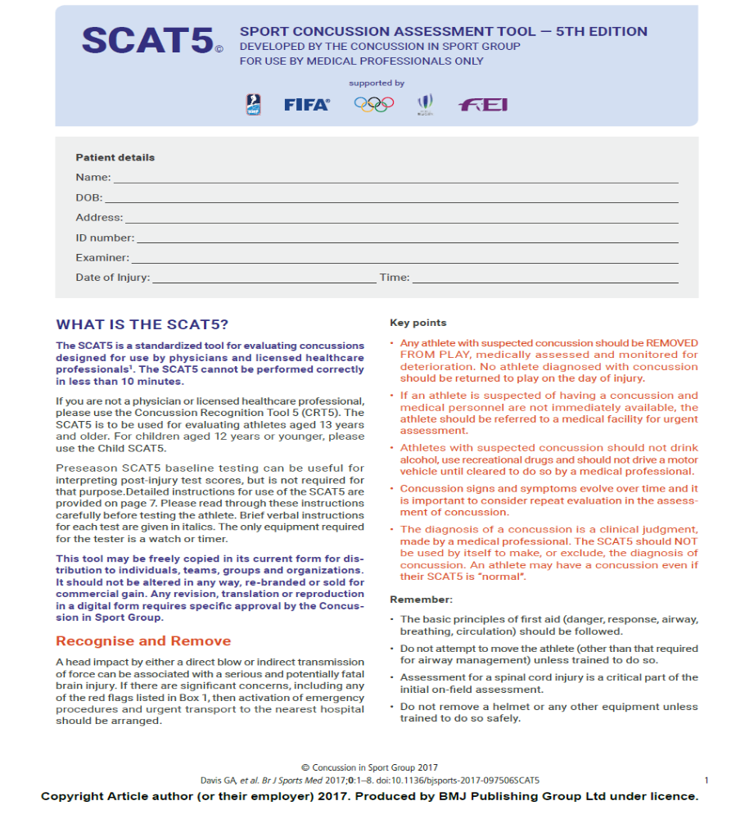

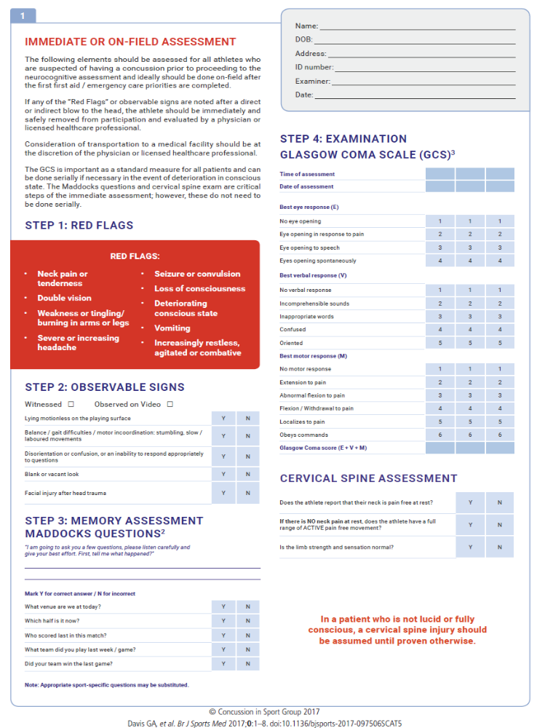
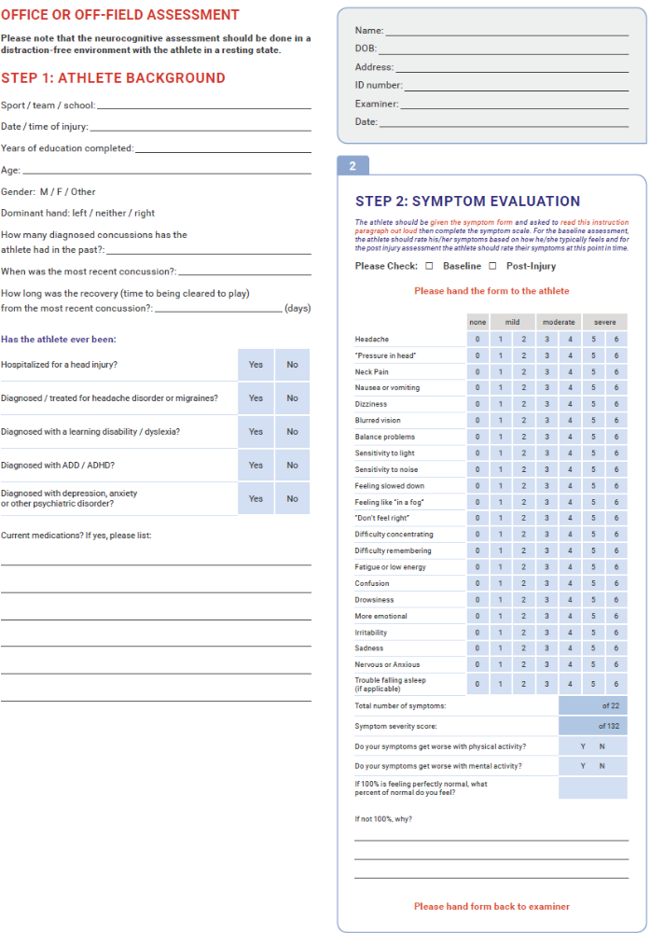
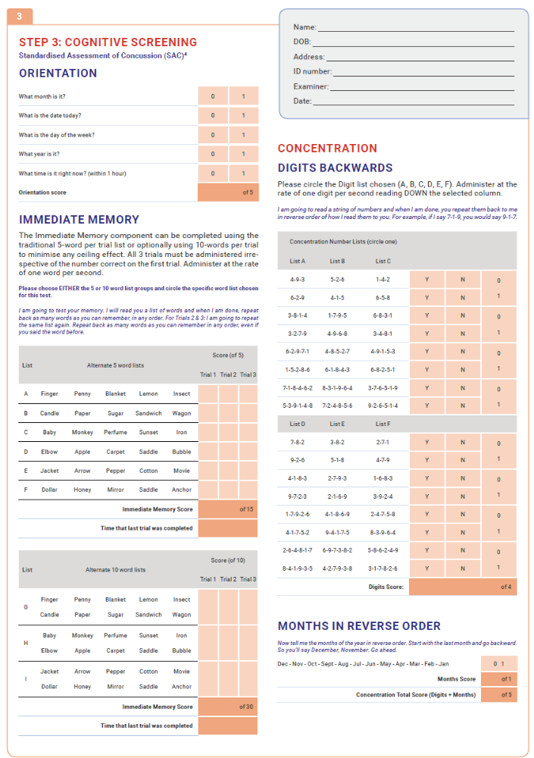
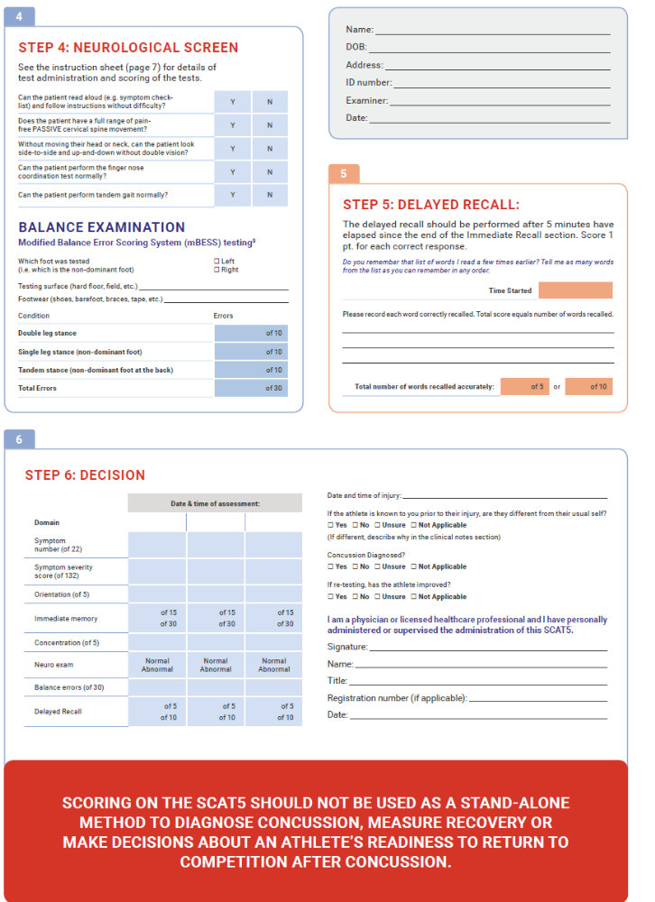
Appendix B - NCAA’S CONCUSSION FACT SHEET FOR STUDENT-ATHLETES
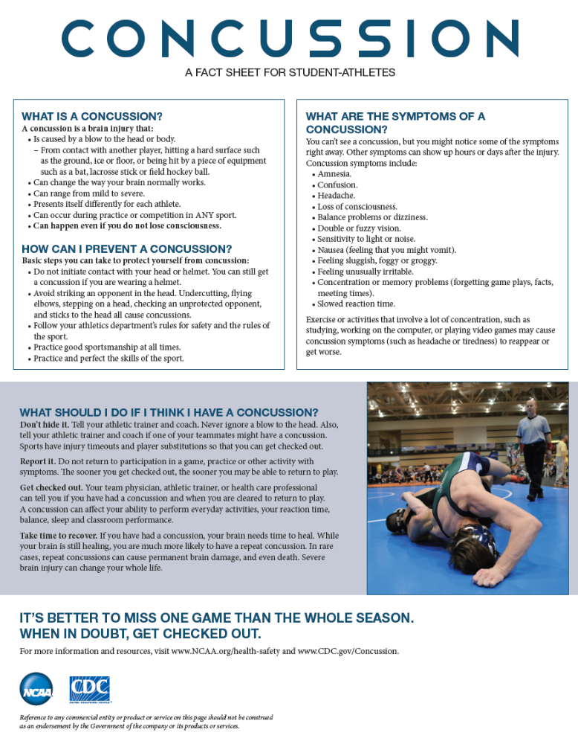
Sources: http://fs.ncaa.org/Docs/health_safety/ConFactSheetsa.pdf

Appendix C – Student Athlete Concussion Education Acknowledgement Statement

Student Athlete Concussion Education Acknowledgement Statement

- I understand that it is my responsibility to report all injuries to my athletic trainer and/or campus physician.

- I have read and understand the NCAA Concussion Fact Sheet

After reading the NCAA Concussion Fact Sheet, I am aware of the following:
Signs & Symptoms of Concussion

Amnesia Sensitivity to light or noise
Confusion Nausea
Headache Feeling sluggish, foggy, or groggy
Loss of consciousness Feeling unusally irritable
Balance problems or dizziness Concentration or memory problems
Double or fuzzy vision Slowed reaction time

__________ A concussion is a brain injury that I must report to my athletic trainer or campus Initial physician.
__________ A concussion can affect my ability to perform everyday activities, and affect Initial reaction time, balance, sleep, and classroom performance.
__________ You cannot see a concussion, but you may notice some of the symptoms right Initial away. Other symptoms can show up hours or days after the injury.
__________ If I suspect a teammate has a concussion, I am responsible for reporting the Initial injury to my athletic trainer or campus physician
__________ I will not return to play in a game or practice if I received a blow to the head or Initial body that reults in concussion-related sypmtoms.
__________ Following a concussion the brain needs time to heal. You are much more likely Initial to have a repeat concussion if you return to play before your symptoms resolve.
__________ In rare cases, repeat concussions can cause permanent brain damage, and even Initial death.

Student Athlete Name (Print) ___________________________________________________
Student Athlete’s Signature __________________________ Date: ____________________
Source: http://fs.ncaa.org/Docs/health_safety/UNC%20Student%20Athlete%20Concussion%20Statement%20Form%2052910.pdf

Appendix D - NCAA’S CONCUSSION FACT SHEET FOR COACHES
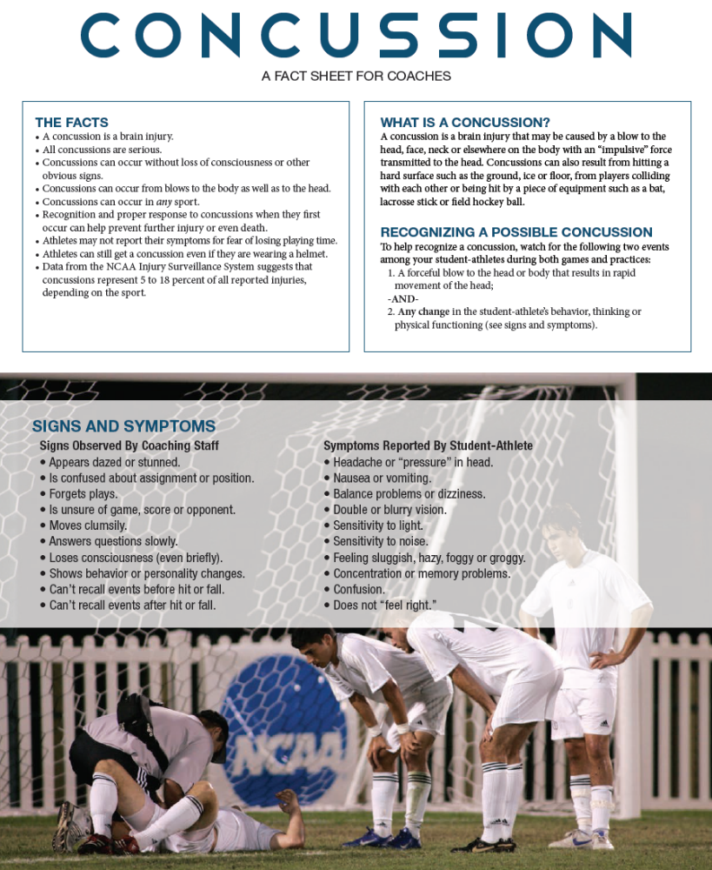

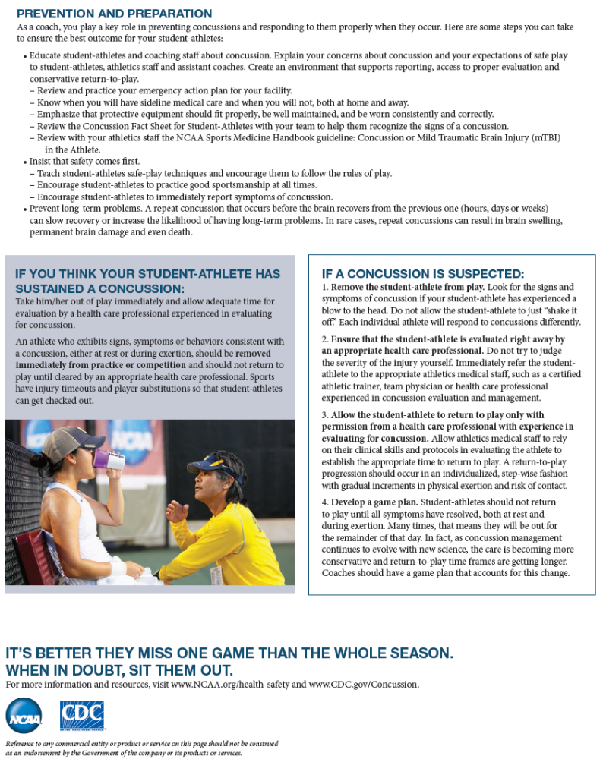
Sources: http://fs.ncaa.org/Docs/health_safety/ConFactSheetcoaches.pdf
Appendix E - Coaches Concussion Education Acknowledgement Statement

Coaches Concussion Education Acknowledgement Statement

- I have read and understand the UB Concussion Policy.

- I have read and understand the NCAA Concussion Fact Sheet for coaches.

After reading the NCAA Concussion Fact Sheet for coaches, I am aware of the following:

__________ A concussion is a brain injury that an athlete must report to the athletic trainer Initial or campus physician.
__________ A concussion can affect the athletes’s ability to perform everyday activities, and Initial affects reaction time, balance, sleep, and classroom performance.
__________ You cannot see a concussion, but you may notice some of the symptoms right Initial away. Other symptoms can show up hours or days after the injury.
__________ If I suspect an athlete has a concussion, I am responsible for reporting the Initial injury to the athletic trainer or campus physician.
__________ I will not knowingly allow an athlete to return to play in a game or practice if Initial he/she received a blow to the head or body that reults in concussion-related sypmtoms.
__________ Following a concussion the brain needs time to heal. Concussed athletes are Initial much more likely to have a repeat concussion if they return to play before their symptoms resolve. In rare cases, repeat concussions can cause permanent brain damage, and even death
__________ I am aware that every first-year student-athlete participating on specified
Initial teams must be baseline tested prior to participation in sport. These tests allow
for comparison of symptoms, neurocognition, and balance if the athlete were to
become injured.
__________ I am aware that athletes diagnosed with a concussion will be assessed
Initial once symptoms have resolved. Athletes will begin a graduated
return to play protocol following full recovery of neurocognition and balance.

Coach’s Name (Print) ___________________________________________________
Coach’s Signature __________________________ Date: ____________________
Source: http://www.hokiesports.com/sportsmed/resources/concussion-statement-coaches.pdf

Appendix F – References
References

- NCAA & CDC Educational Material on Concussion in Sport. Available online at www.ncaa.org/health-safety.
- NCAA Sports Medicine Handbook. 2014-2015.
- NCAA Sport Science Institute Newsletter. Vol 1, Issue 2, 2013.
- National Athletic Trainers’ Association Position Statement: Management of Sport Concussion. Journal of Athletic Training, 2014; 49(2).
- Consensus Statement on Concussion in Sport; the 4th International Conference on Concussion in Sport Held in Zurich, November, 2012. British Journal of Sports Medicine, 2013; 47: 250-258.
- University of North Carolina Wilmington Concussion Management Policy. 2015.

